Research questions for CDI transmission and case ascertainment model
Model 1 (Figure 1) is designed to focus on diagnostic testing of hospital patients with CDI.
It can be used to quantify the effect of a) testing algorithm sensitivity; b) testing result turnaround time; c) location of suspected cases awaiting test results (i.e. on a general ward or isolated in a side-room); and d) testing coverage for symptomatic hospital patients with CDI on:
- case ascertainment;
- transmission of CDI;
- hospital resource use;
- hospital patient mortality.
Outcomes of interest
Case ascertainment:
- the proportion of incident CDI cases amongst hospital patients (to include patients that progress to CDI during their hospital stay and those admitted with CDI) that are confirmed through diagnostic testing;
- the proportion of incident CDI cases that are missed (i.e. discharged from, or die in hospital without a CDI diagnosis having not been tested, or following a false-negative test result); and
- the proportion that are confirmed through re-testing following a false-negative test result (delayed diagnosis).
Transmission of CDI:
- the incidence of hospital-acquired CDI, i.e. patients that become colonised and progress to CDI during their hospital stay;
- the incidence of hospital-acquired colonisation with C. difficile, i.e. patients that become colonised during their hospital stay; and
- the difference in prevalence of colonisation and infection amongst discharged and admitted patients.
Hospital resource use:
- total hospital bed occupancy, reflecting any impacts on bed pressure and average patient length of stay;
- the proportion of hospital total hospital bed occupancy that is required for patient isolation in a side room;
- the number of faecal specimens collected and tested for CDI.
Hospital patient mortality:
- incidence of death among hospital patients;
- the proportion of hospital deaths that occur among patients following progression to CDI in hospital or admission with CDI; and
- the proportion of hospital deaths that occur among missed CDI cases (to include untested and false negative cases).
Options for model development (in order of priority)
- Inclusion of hospital resource costs (specimen collection and testing, side room versus general ward patient care, CDI treatment) and patient welfare values (QALY losses). This option is high priority because it would not require additional complexity in the transmission modelling, and would allow comparison of multiple outcomes within a single metric (£ cost per avoided QALY loss, or £ cost per avoided hospital-acquired CDI case), and an assessment of the value of improving information on testing algorithm sensitivity.
- Inclusion of states for symptomatic and asymptomatic susceptible and colonised patients, along with states for testing and treatment of symptomatic susceptible and colonised patients (Figure 2). This option is medium priority because whilst it would add some complexity in the transmission modelling, it is not expected to make a large difference in transmission outcomes. It would reduce the transmission from symptomatic patients colonised with C. difficile that are identified as suspected CDI cases and isolated in a side room for testing and/or treatment.
It would broaden the scope of the model, to focus on CDI diagnostic testing of hospital patients with diarrhoea. The main benefit of broadening the model in this way would be to allow evaluation of testing coverage and testing algorithm specificity on hospital resource use (unnecessary patient isolation, treatment and side room use). However, there may be insufficient evidence to parameterise the incidence of diarrhoeal symptoms amongst susceptible and colonised patients, and prevalence among admitted patients.
- Separation of testing states into two or three steps (with transition between testing stages reflecting the sensitivity, specificity and turnaround time for each test) (Figure 3). This would allow evaluation of the effect of different testing algorithms (e.g. 3-step testing for GDH/toxins/toxigenic DNA versus 2-steps for toxigenic DNA/toxins) on unnecessary patient isolation, treatment and side room use, and permit variation in the sensitivity, specificity and turnaround time for each testing step rather than summarising these for the testing algorithm.
This option is medium priority because it would add considerable complexity to the model, but is not expected to make a large difference to case ascertainment or transmission. The main benefits of separating the testing steps would be to allow for a reduced cost of testing and shorter isolation period for patients that screen negative (assuming a faster turnaround time for screening than for the whole testing algorithm). In practice, it may not be possible to parameterise a 3-step testing algorithm, as there is insufficient evidence on the sensitivity of tests for toxigenic DNA on GDH-positive specimens.
- Inclusion of a state for CD spore stock, to allow environmental transmission to vary with historic prevalence of colonised and infected patients. Additions to the CD spore stock would vary with the prevalence of colonised and infected patients in each time step, and wane at a constant rate to reflect the average period of spore persistence in the hospital environment. The environmental transmission parameter would vary with the size of spore stock. This option is medium priority, as there may be insufficient evidence to set parameter values.
- Inclusion of a continuous variable for the proportion of suspected cases that are isolated in side rooms while awaiting test results, rather than assuming either all or none are isolated for testing. This would impact on the transmission from patients identified as suspected cases. This option is low priority as it would also require additional testing states, increasing model complexity for little additional information. The current model design provides best- and worst-case outcomes for demand for side-room beds, depending on whether patients are isolated while awaiting test results.
- Inclusion of additional states for treatment of cases confirmed by re-testing following a false negative test result, to reflect a potential increase in disease severity (requiring longer/alternative treatment) and mortality due to delayed diagnosis. This option is low priority as it would require additional treatment states, increasing model complexity with insufficient evidence to set parameter values. The current model design captures this effect to some extent, as false negative patients have a longer length of stay than true positives, in a state with a mortality rate that reflects their infected and untreated status.

Figure 1
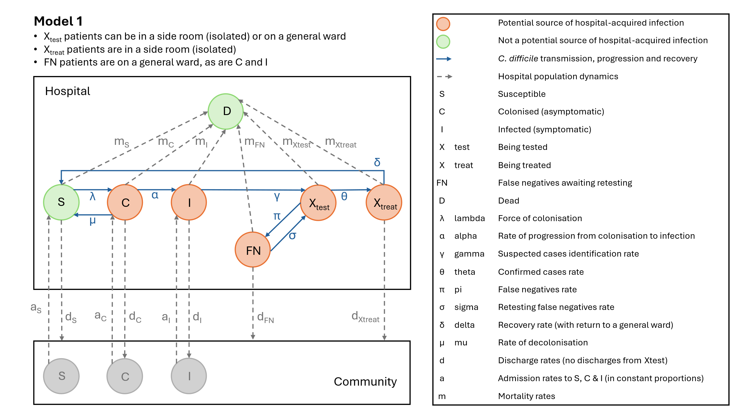

Figure 2
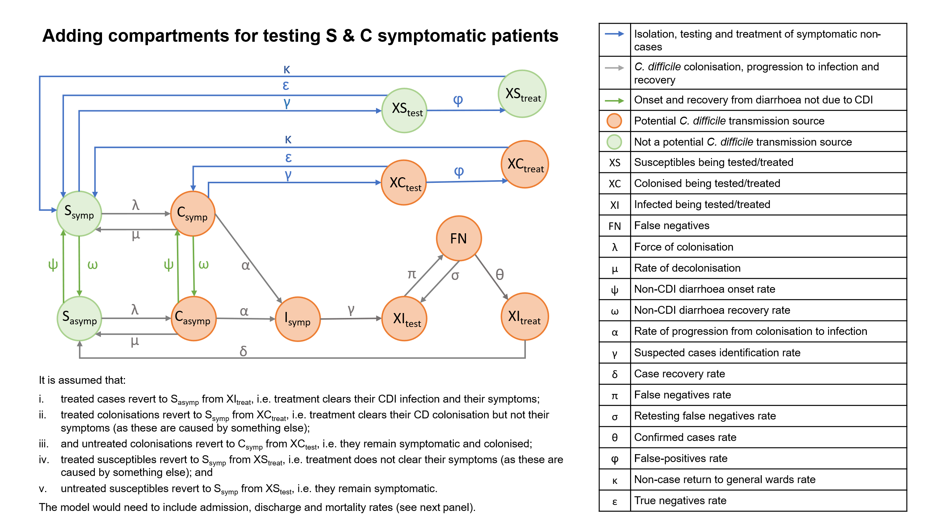
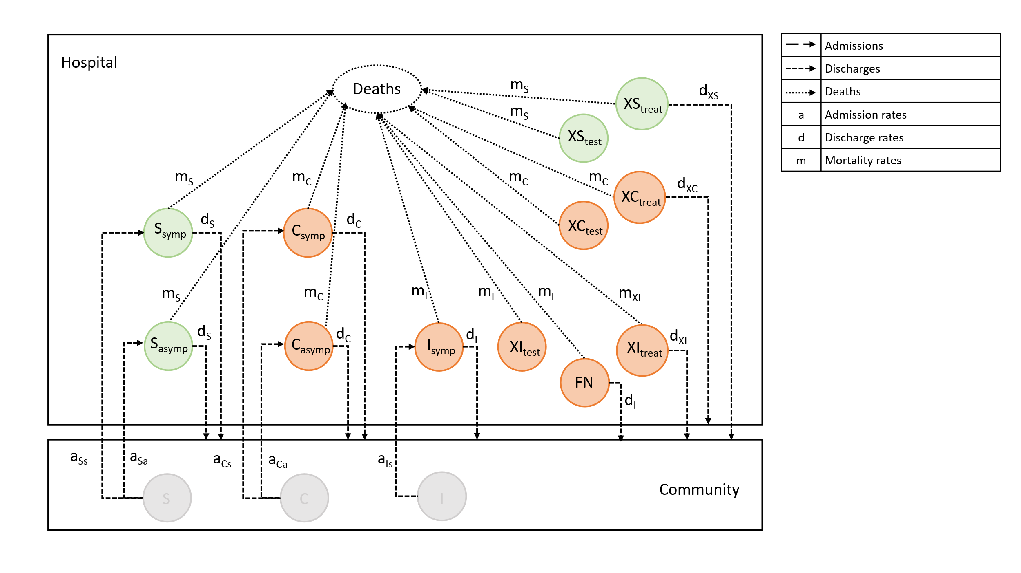

Figure 3
Flow diagram showing possible outcomes for 3-step CDI diagnostic testing of hospital patients with diarrhoeal symptoms (spacing left to right represents time)
